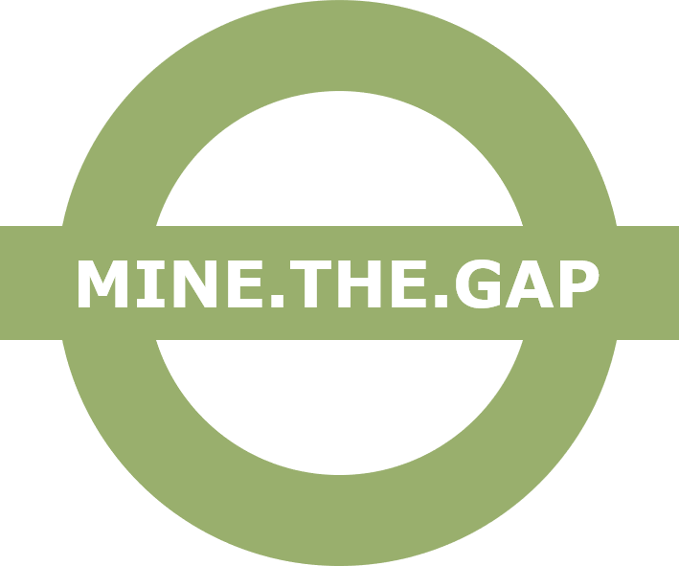

Ethic Issues Declaration

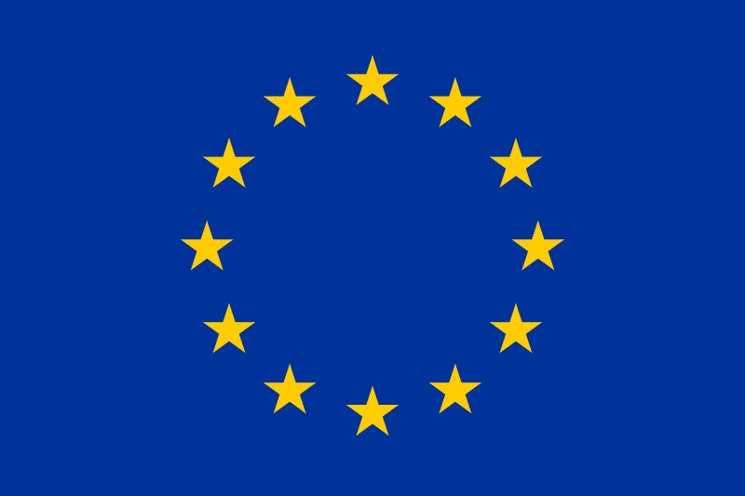 | This project has received funding from the European Union’s Horizon 2020 research and innovation programme under Grant Agreement No. 873149  Topic: H2020-INNOSUP-01-2018-2020  Ethic Issues declaration
Ethics issues table (to be uploaded as Annex 1 of full proposal)

Full-Proposal includes “Ethics issues table” that must be filled in with yes/no.
Applicants should always describe any relevant ethical aspects in their research plans. If a research permit or a statement by an ethics committee is required for the implementation of the project, applicants shall provide information on the permits or permit proposals.
In case ethical issues apply applicants should mark respective issues in the table, MINE.THE.GAP consortium and open calls transparency committee will advise on further steps for project implementation.
ETHICS ISSUES | YES/NO | PROPOSAL SECTION Nº
1. GENDER EQUALITY
Does your company do gender discrimination?
Does your company have equal access to employment, work and training?
Does your research/innovation go against gender equality?
Does your research go against human rights?
2. WORKER
Does your company respect its workers and their rights?
Does your research/innovation go against worker’s rights?
3. ENVIRONMENT
Does your company respect current environment legislation in your country?
Does your company promote good environmental practices in the exercise of its work activity?
Does your innovation deal with endangered fauna and/or flora and/or protected areas?
4. CHEMICAL ISSUES
Does your company use dangerous chemicals in accordance with current legislation?
Does your research/innovation use dangerous chemicals?
If yes, do these dangerous chemicals your research involve put in danger the health human, including research staff, or fauna and/or flora and/or protected areas?

NAME AND POSITION OF THE SIGNATORY, BEING AUTHORISED TO REPRESENT THE COMPANY:
I DECLARE ON MY HONOUR, THE ACCURACY OF THIS DECLARATION AND OF ANY ANNEXES THERE TO.
PLACE AND DATE:
SIGNATURE:

This project has received funding from the European Union’s Horizon 2020 research and innovation programme under Grant Agreement No. 873149
Topic: H2020-INNOSUP-01-2018-2020

