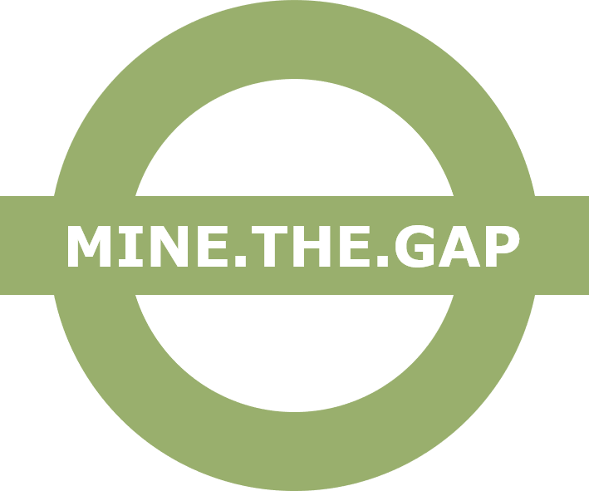

Financial Declaration for SMEs innovation vouchers

Financial Declaration

Identification of the applicant enterprise
Name or business name
Address
Registration (VAT number)
Names and titles of principle(s) director(s)

Category of enterprise
 | Y*-2 | Y*-1 | Y*
Year
Annual Turnover
Number of employees
Balance sheet total
*Y = Last closed financial year

By signing this document, you declare that your enterprise is in alignment with all the following situations:
- Is considered a SME (Small and Medium-size Enterprise) according to the EU definition.
- Has not been declared bankrupt, has initiated bankruptcy procedures or being wound up, has not entered into an arrangement with creditors, has not suspended business activities, is not the subject of proceedings concerning those matters or is not any analogous situation arising from a similar procedure provided for in national legislation or regulations.
- Is in compliance with its obligation relating to the payment of social security contributions and the payment of taxes, in accordance with the legal provisions of the country in which it is established.
- Has not convictions for fraudulent behaviour, other financial irregularities, unethical or illegal business practices.
- Is not under liquidation or an enterprise under difficulty accordingly to the Commission Regulation No 651/2014 art. 2.18.

Name and position of the signatory, being authorised to represent the enterprise:
Name:

Position:

I declare on my honour that:
- I understand the above-mentioned rules;
- The accuracy of this declaration and of any annexes thereto;
- Name or business name is in alignment with the above-described legal and financial situations.
Date:
Signature and Stamp:

Additional Financial Documents

The applicant enterprise must have the financial capacity to carry out the actions described in its proposal and to properly manage the financial support granted to it. Applicants must attest their financial solvency providing documents under at least one of the following options:
- Official copy of the profit and loss account, and balance sheet for the last two years for which accounts have been closed, demonstrating financial capability greater or equal to the amount of the grant requested by the applicant.
- Official declaration of invested capital greater or equal to 25,000 EUR.
- Detailed declaration specifying awarded funding and describing the participation of the company in National or International (i.e. EU funds) grants or funded actions/projects for a value greater or equal to the amount of the grant requested by the applicant. Attachment of the official grant agreements is compulsory (non-relevant phrases/figures can be redacted).
- One of the following bonding documents that ensures the fulfilment of the voucher grant agreement and its annexes or compensation:
  - Dedicated escrow account holding a balance greater or equal to the grant requested by the applicant.
  - Notarised guarantee between parties greater or equal to the amount of the grant requested by the applicant, plus a bank statement/s proving that the guarantor holds more than that amount in its account/s balance.
Applicants not attaching the additional financial documents will be considered not eligible and therefore their applications rejected. Exceptionally, MINE.THE.GAP consortium may consider evidence/documents other than those mentioned above as acceptable, if they provide greater guarantees, or on a temporary basis, while the required documents are being processed or corrected. In the latter case, it may extend the deadlines for issuing its decision on eligibility. MINE.THE.GAP reserves the right to request any other document for verification of the applicant’s financial capacity and SME status.

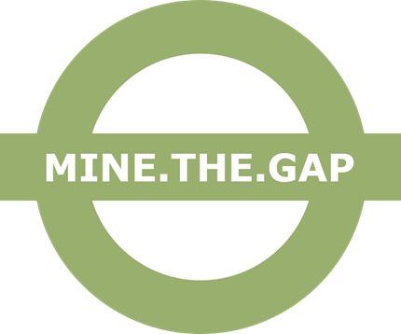

Chairman (CEO), Executive manager or equivalent
https://ec.europa.eu/growth/smes/sme-definition_en

